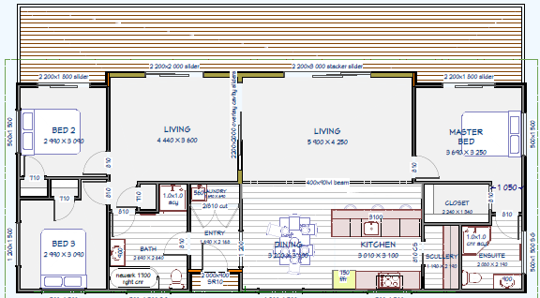
HEALEY FLOOR PLAN

